Example 1 # of children and Age when first married

FREQUENCIES
VARIABLES=childs agewed
/STATISTICS=STDDEV MEAN MEDIAN MODE SKEWNESS SESKEW
/HISTOGRAM NORMAL
/ORDER= ANALYSIS .

Frequencies

[DataSet1] C:\Documents and Settings\matsuoh\My Documents\RM530\Data\GSS 1993 (selected for income).sav

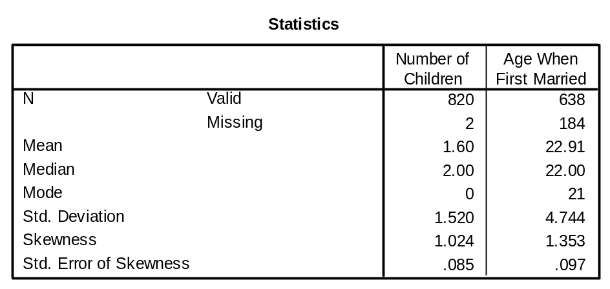

Frequency Table

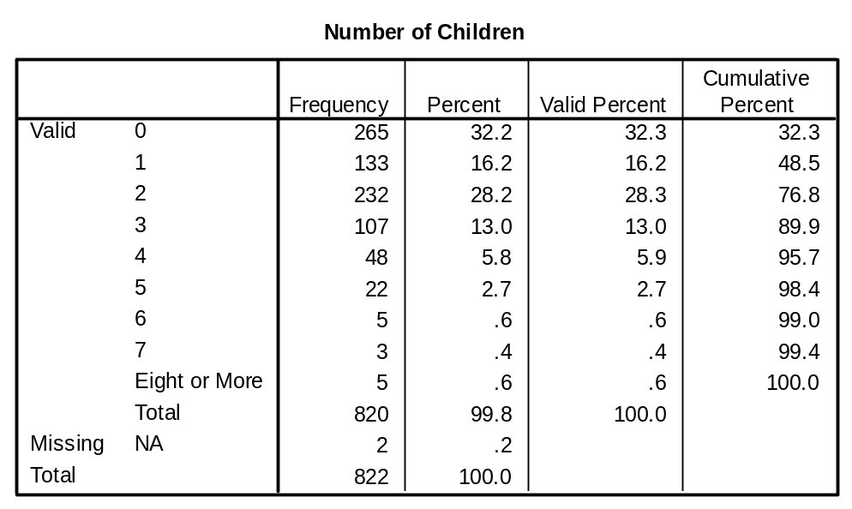

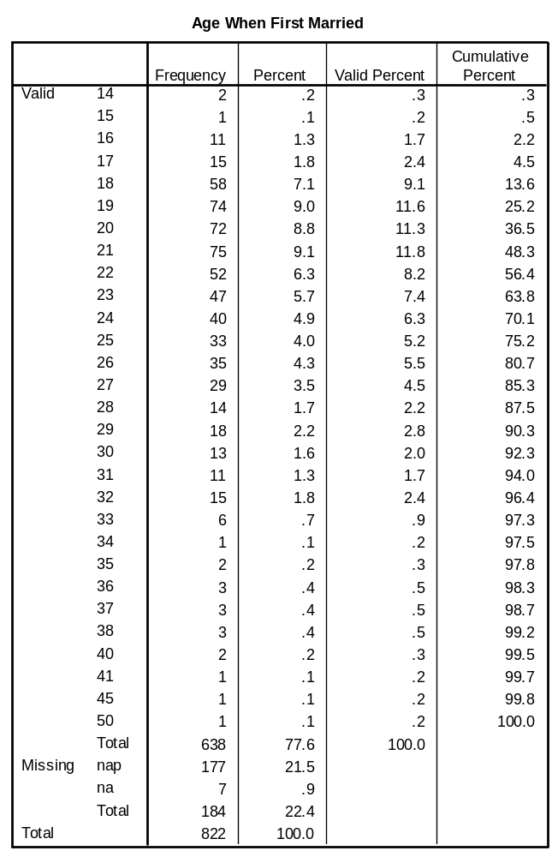

Histogram

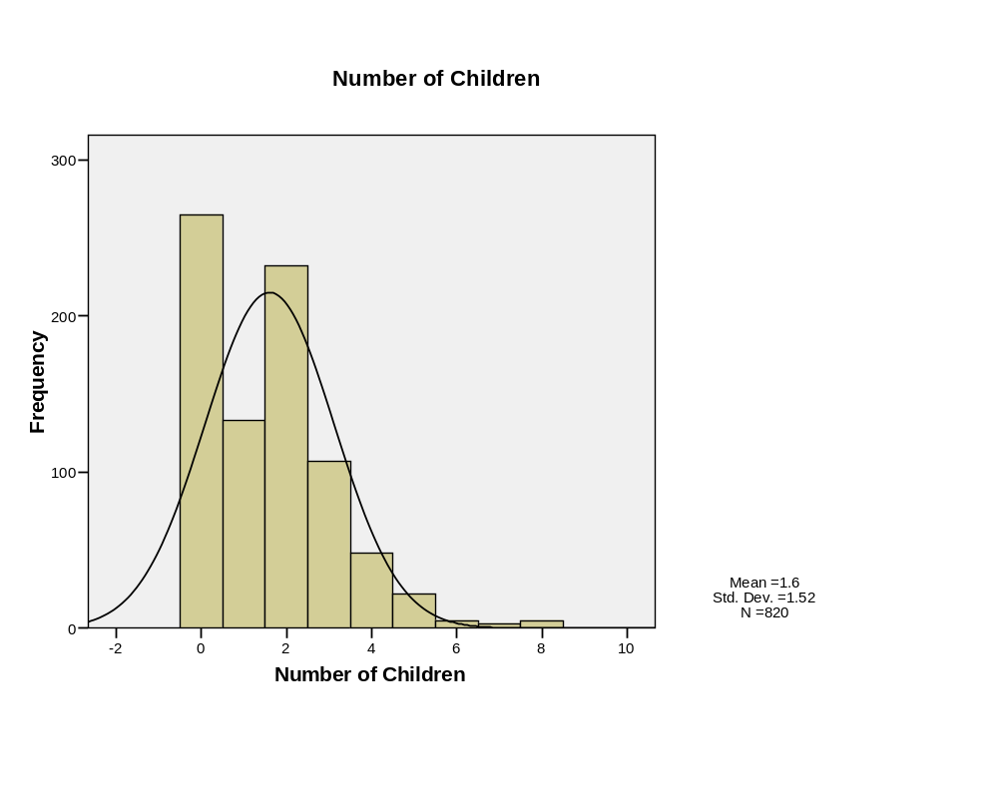
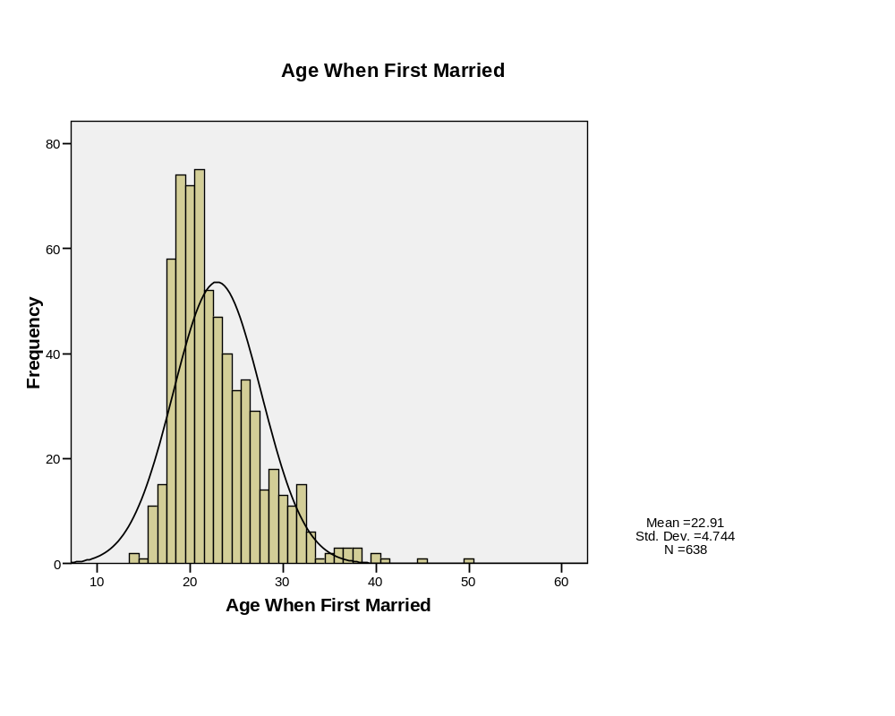
REGRESSION
/MISSING LISTWISE
/STATISTICS COEFF OUTS R ANOVA
/CRITERIA=PIN(.05) POUT(.10)
/NOORIGIN
/DEPENDENT childs
/METHOD=ENTER agewed
/SCATTERPLOT=(*ZRESID ,childs )
/RESIDUALS HIST(ZRESID) NORM(ZRESID)
/CASEWISE PLOT(ZRESID) OUTLIERS(2) .

Regression

[DataSet1] C:\Documents and Settings\matsuoh\My Documents\RM530\Data\GSS 1993 (selected for income).sav

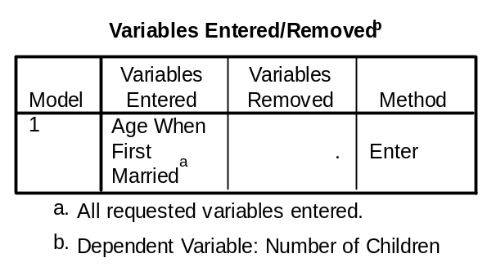

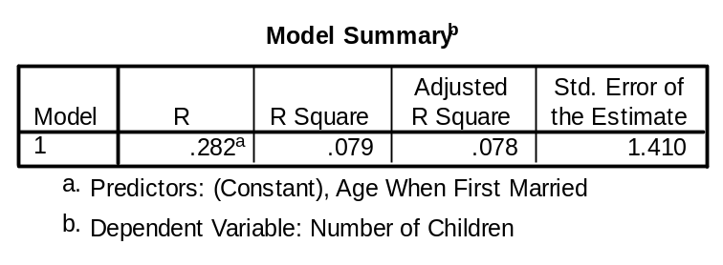

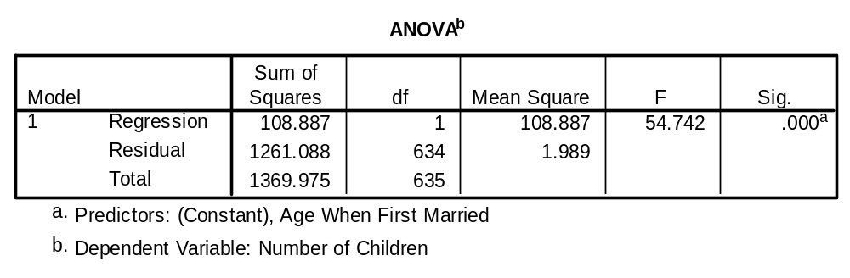

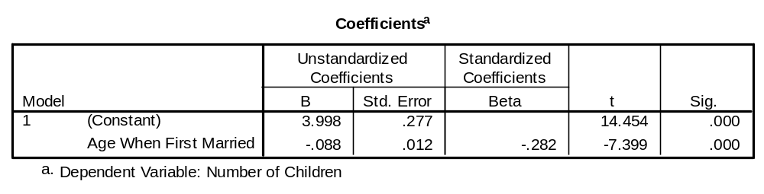

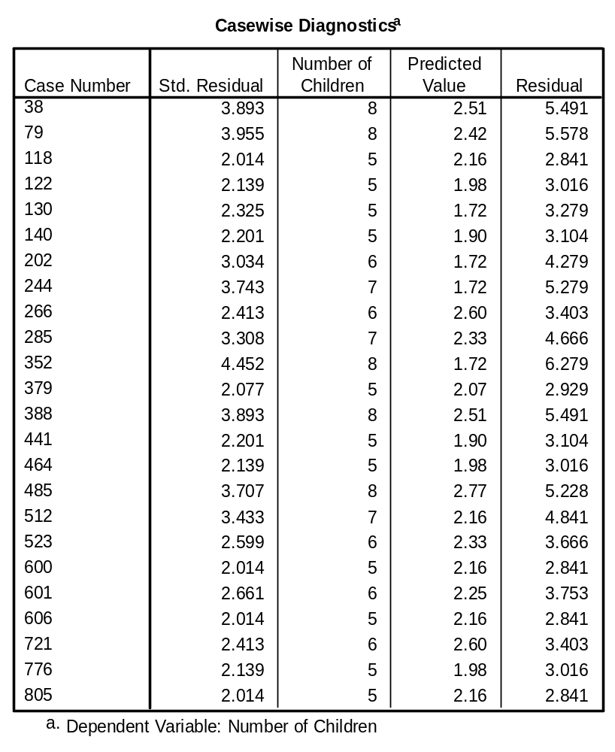

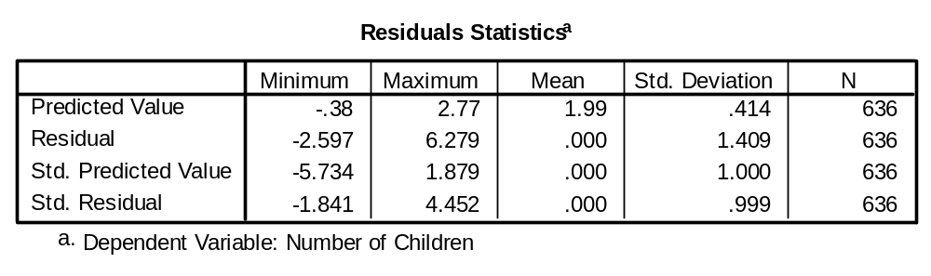

Charts

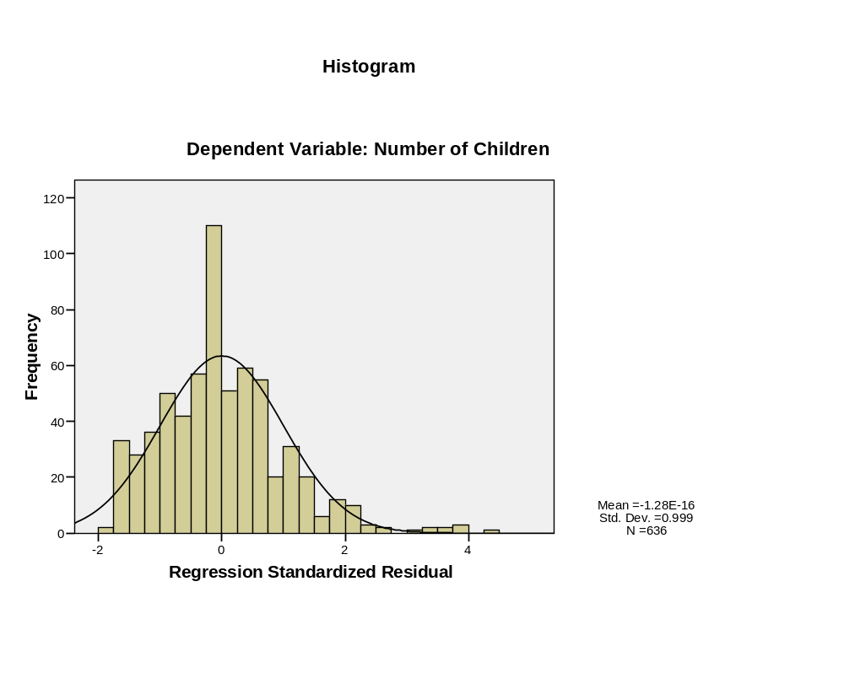
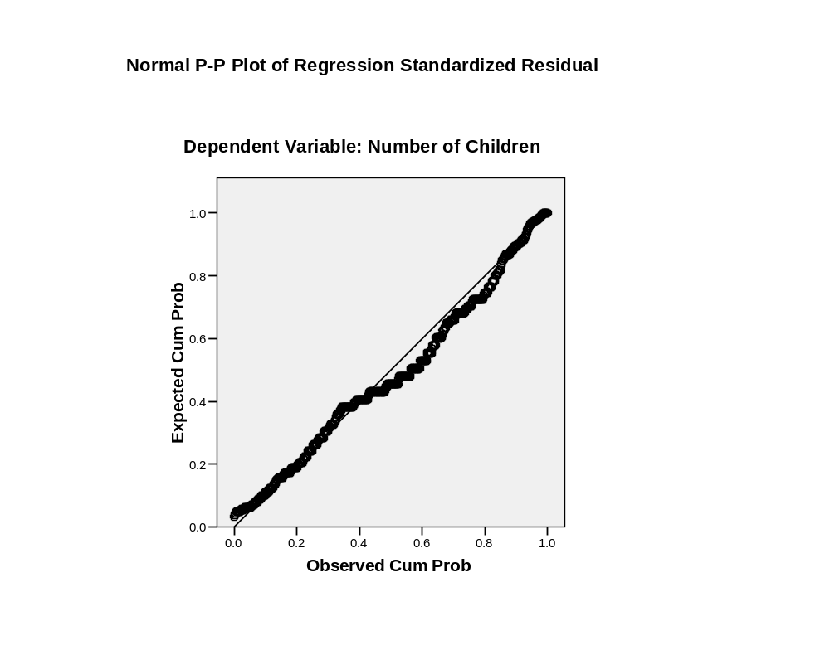
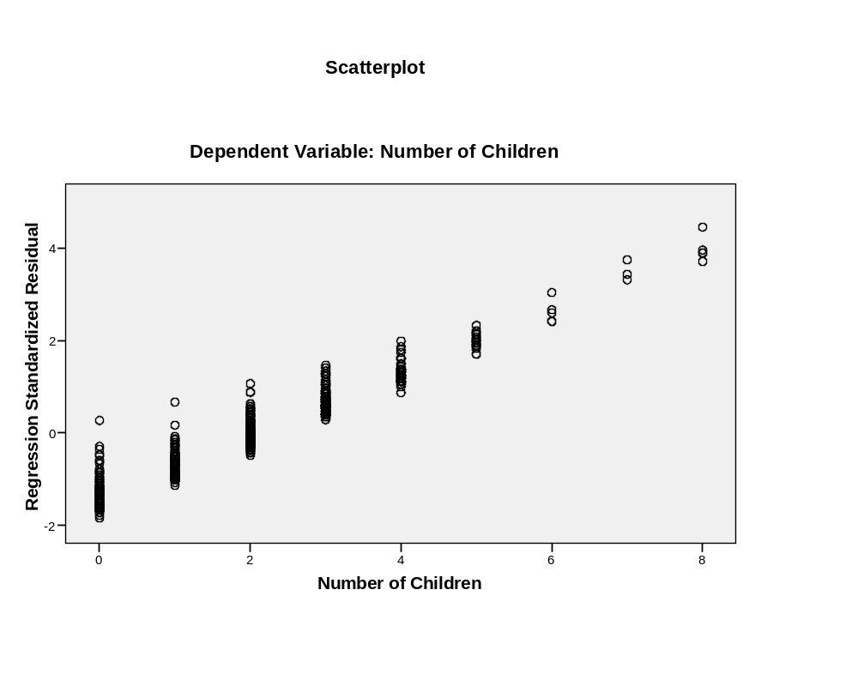
Log transformation of Age when first married

REGRESSION
/MISSING LISTWISE
/STATISTICS COEFF OUTS R ANOVA
/CRITERIA=PIN(.05) POUT(.10)
/NOORIGIN
/DEPENDENT childs
/METHOD=ENTER logagewed
/SCATTERPLOT=(*ZRESID ,childs )
/RESIDUALS HIST(ZRESID) NORM(ZRESID)
/CASEWISE PLOT(ZRESID) OUTLIERS(2) .

Regression

[DataSet1] C:\Documents and Settings\matsuoh\My Documents\RM530\Data\GSS 1993 (selected for income).sav

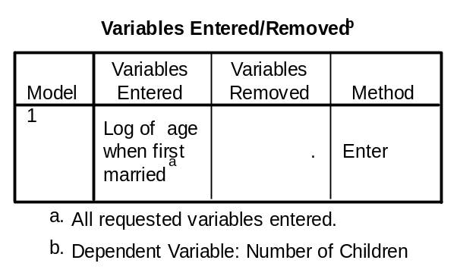

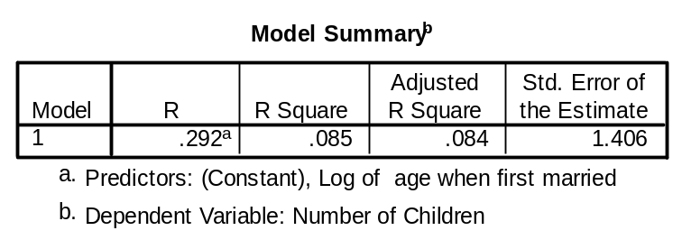

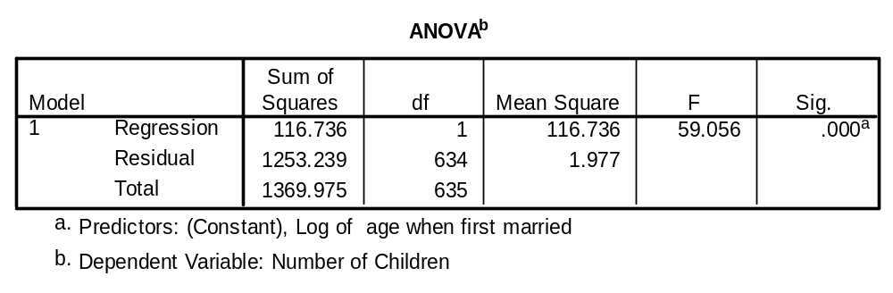

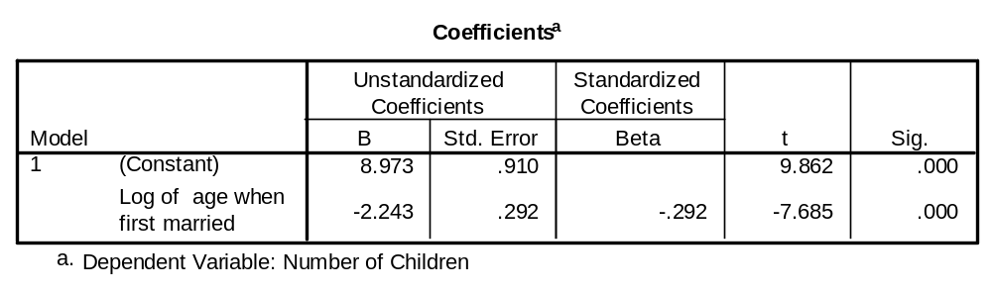

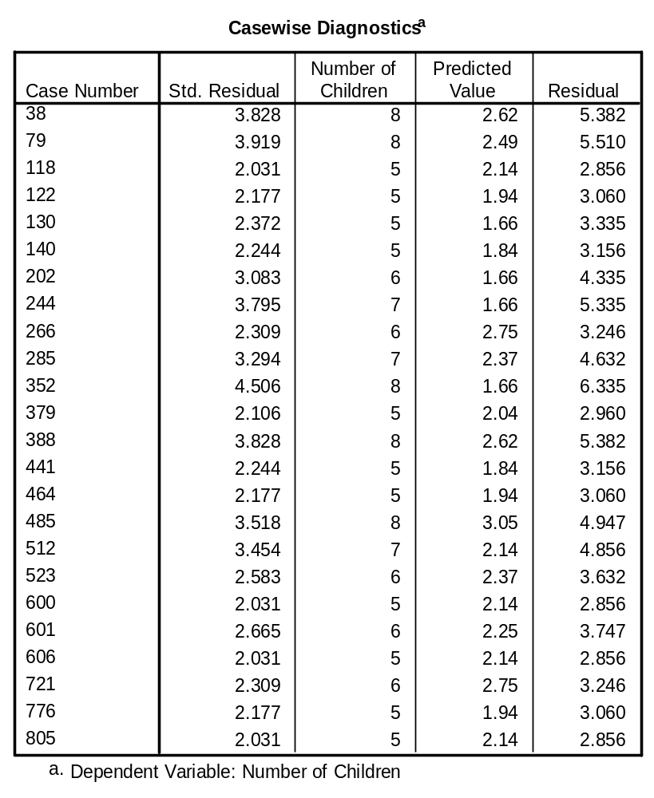

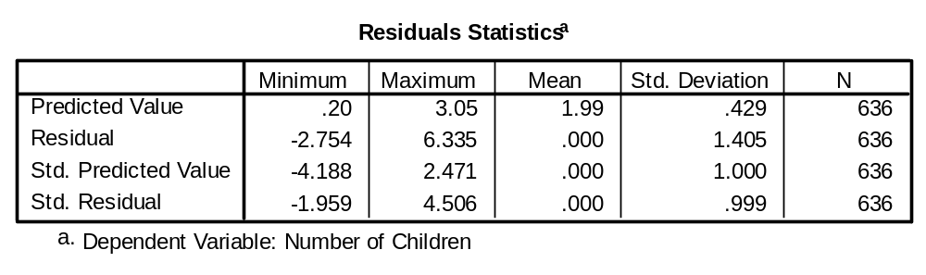

Charts

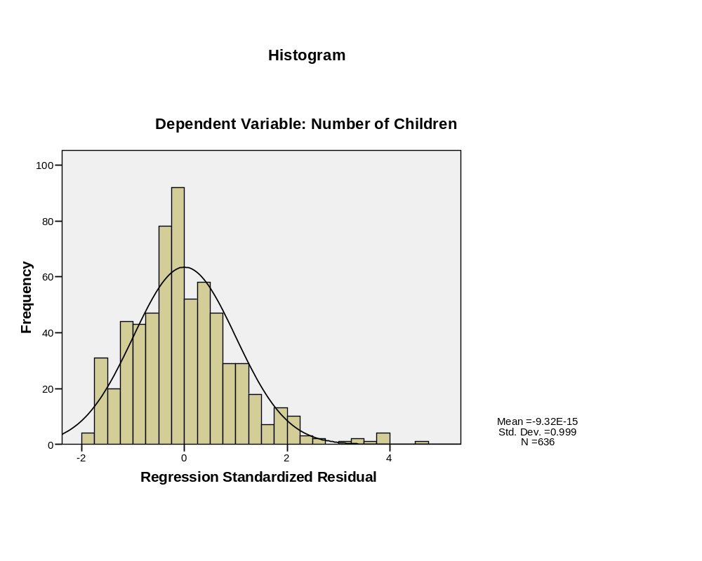
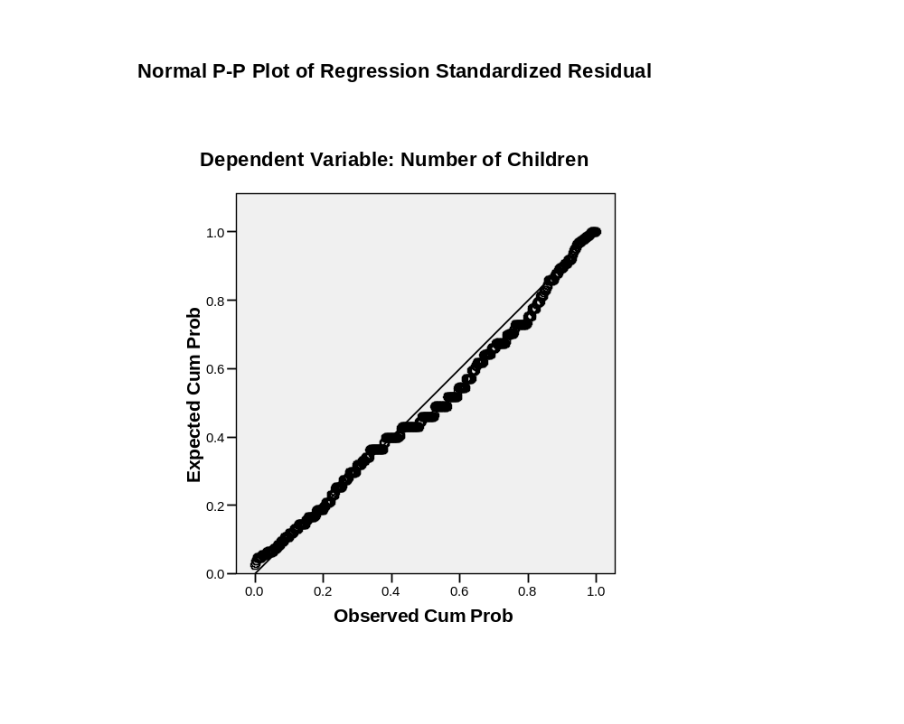
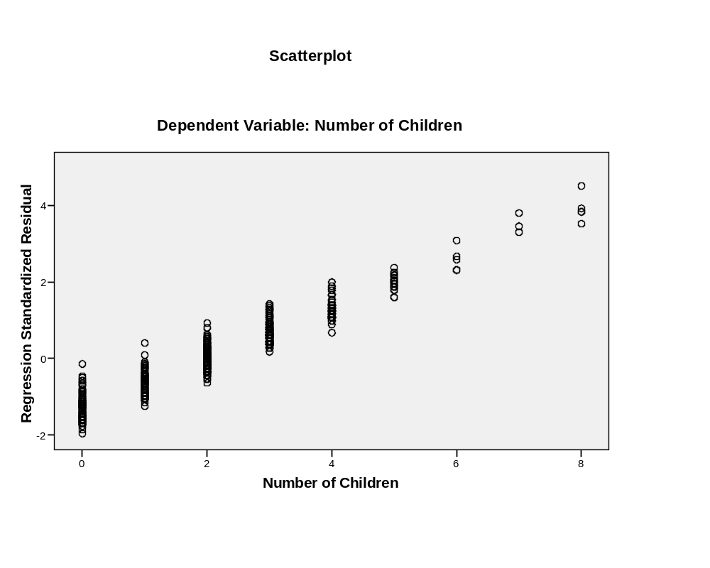

Example 2 Population increase and Birth rate per 1000

FILTER OFF.
USE ALL.
EXECUTE .
SAVE OUTFILE='C:\Documents and Settings\matsuoh\My Documents\RM530\Data\GSS 1993
(selected for income).sav'
/COMPRESSED.
GET
FILE='C:\Program Files\SPSS\World95.sav'.
DATASET NAME DataSet2 WINDOW=FRONT.
FREQUENCIES
VARIABLES=pop_incr birth_rt /FORMAT=NOTABLE
/STATISTICS=STDDEV MEAN MEDIAN MODE SKEWNESS SESKEW
/HISTOGRAM NORMAL
/ORDER= ANALYSIS .

Frequencies

[DataSet2] C:\Program Files\SPSS\World95.sav

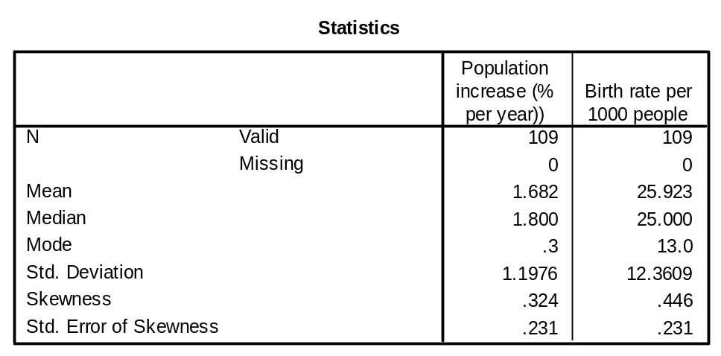

Histogram

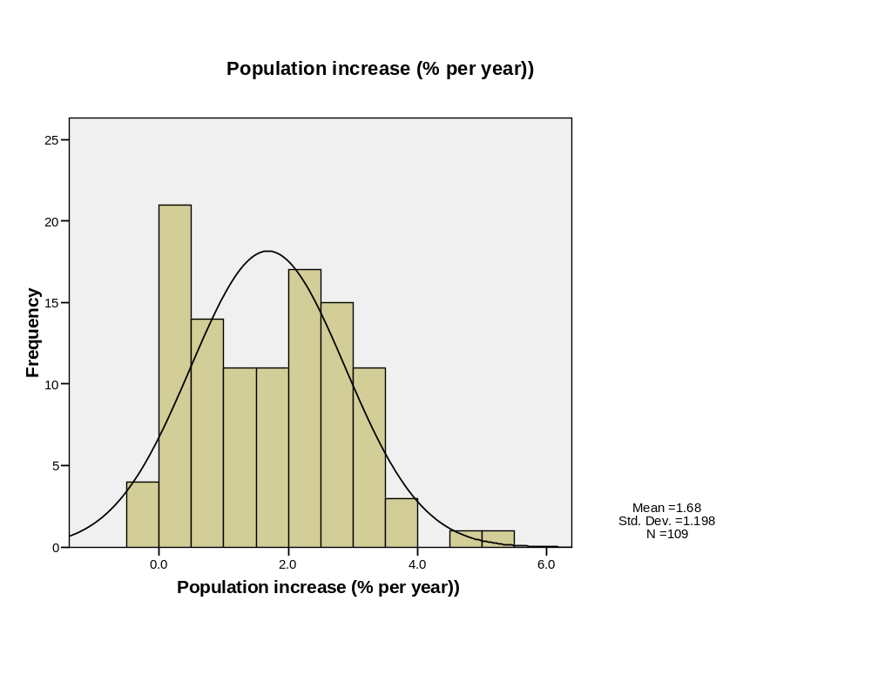
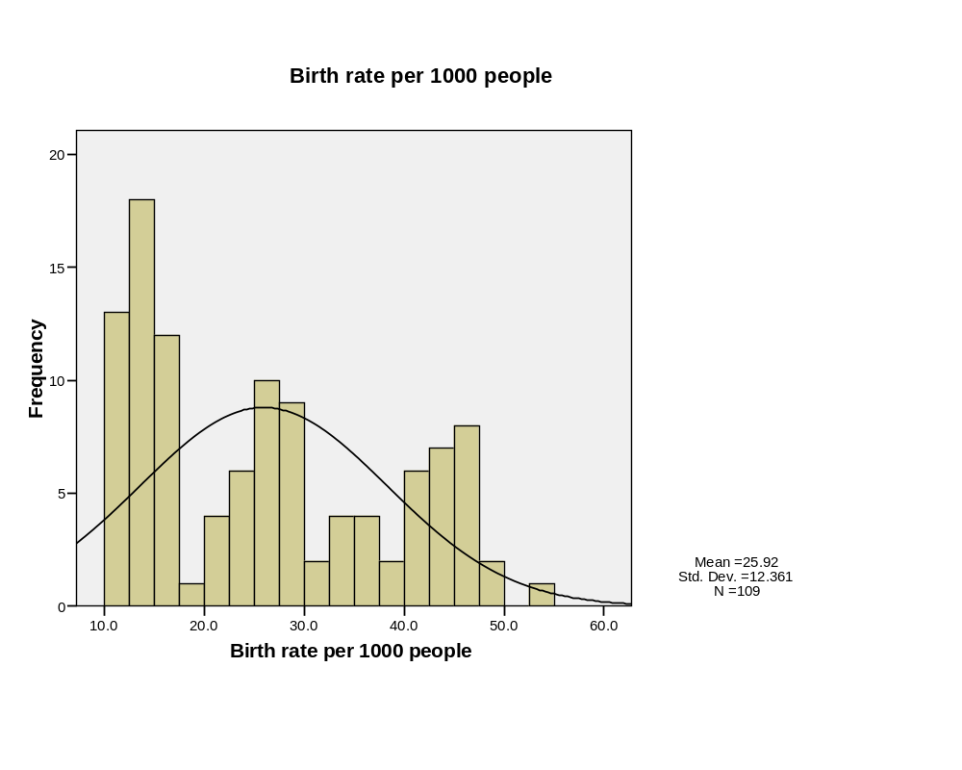
IGRAPH /VIEWNAME='Scatterplot' /X1 = VAR(birth_rt) TYPE = SCALE /Y = VAR
(pop_incr) TYPE = SCALE /COORDINATE = VERTICAL /FITLINE METHOD =
REGRESSION LINEAR LINE = TOTAL SPIKE=OFF /X1LENGTH=3.0 /YLENGTH=3.0
/X2LENGTH=3.0 /CHARTLOOK='NONE' /SCATTER COINCIDENT = NONE.

Interactive Graph

[DataSet2] C:\Program Files\SPSS\World95.sav

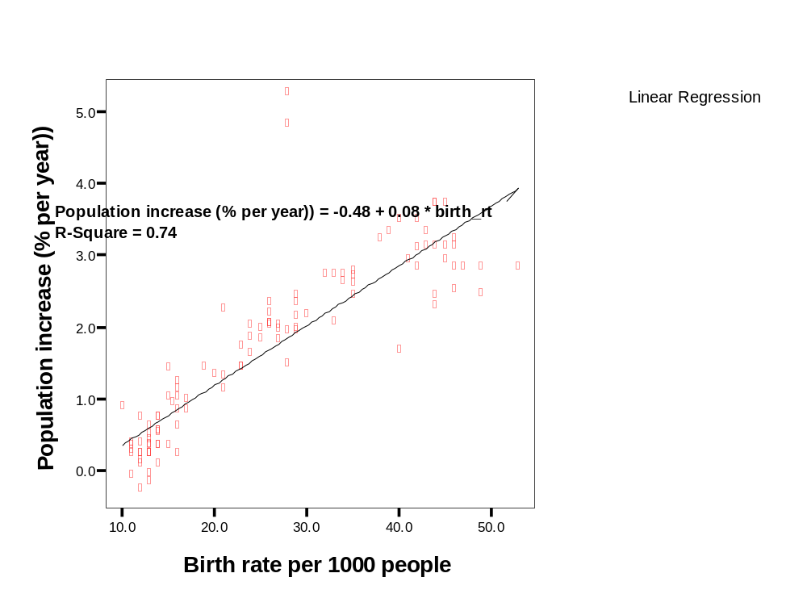

EXE.
REGRESSION
/MISSING LISTWISE
/STATISTICS COEFF OUTS R ANOVA
/CRITERIA=PIN(.05) POUT(.10)
/NOORIGIN
/DEPENDENT pop_incr
/METHOD=ENTER birth_rt
/SCATTERPLOT=(*ZRESID ,pop_incr )
/RESIDUALS HIST(ZRESID) NORM(ZRESID)
/CASEWISE PLOT(ZRESID) OUTLIERS(2) .

Regression

[DataSet2] C:\Program Files\SPSS\World95.sav

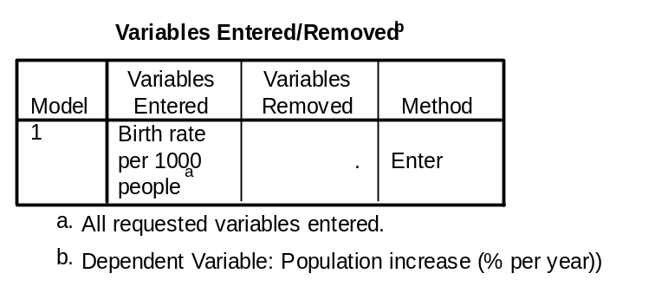

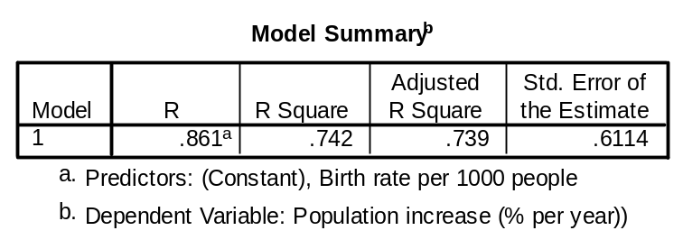

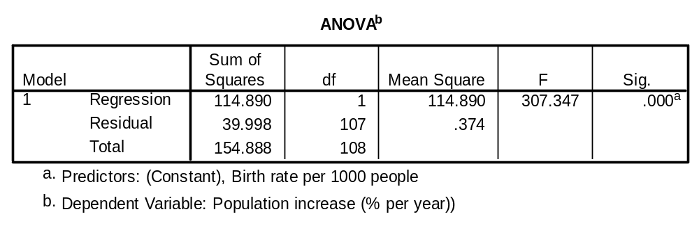

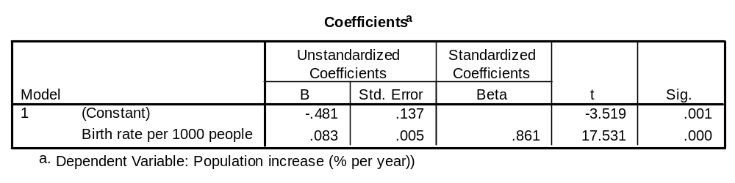

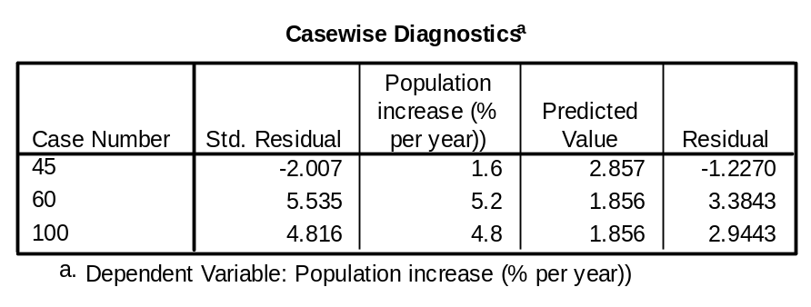

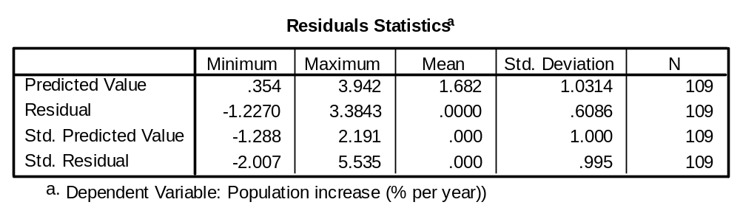

Charts

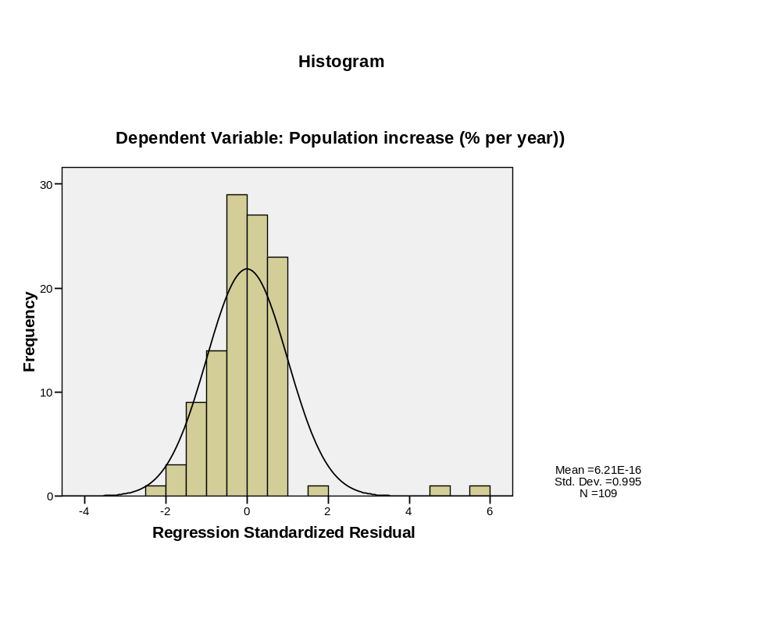
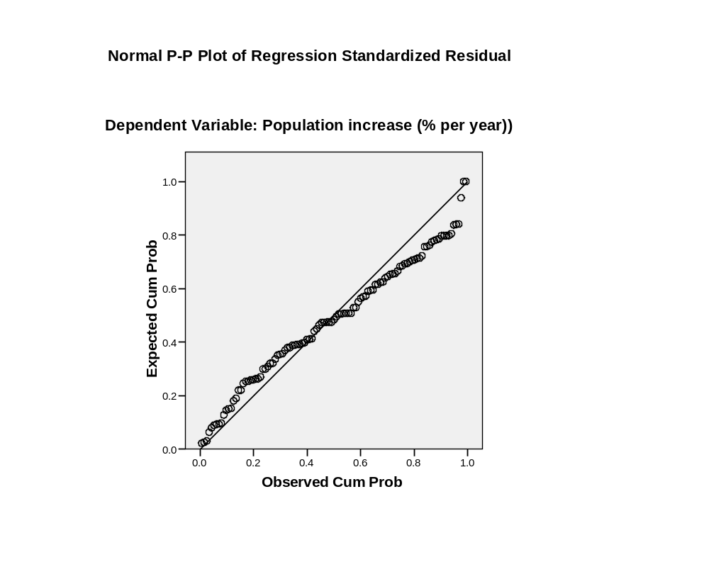

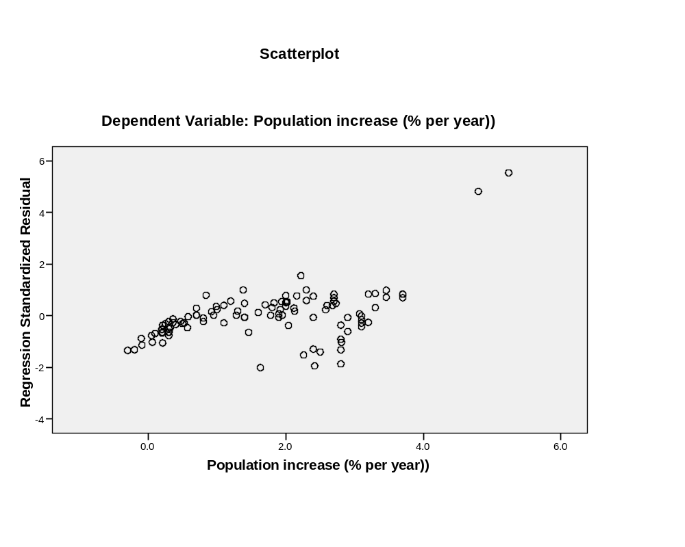

Log transformation of birth rate

COMPUTE logbirth_rt = LN(birth_rt) .
EXECUTE .
IGRAPH /VIEWNAME='Scatterplot' /X1 = VAR(logbirth_rt) TYPE = SCALE /Y = VAR
(pop_incr) TYPE = SCALE /COORDINATE = VERTICAL /FITLINE METHOD =
REGRESSION LINEAR LINE = TOTAL SPIKE=OFF /X1LENGTH=3.0 /YLENGTH=3.0
/X2LENGTH=3.0 /CHARTLOOK='NONE' /SCATTER COINCIDENT = NONE.

Interactive Graph

[DataSet2] C:\Program Files\SPSS\World95.sav

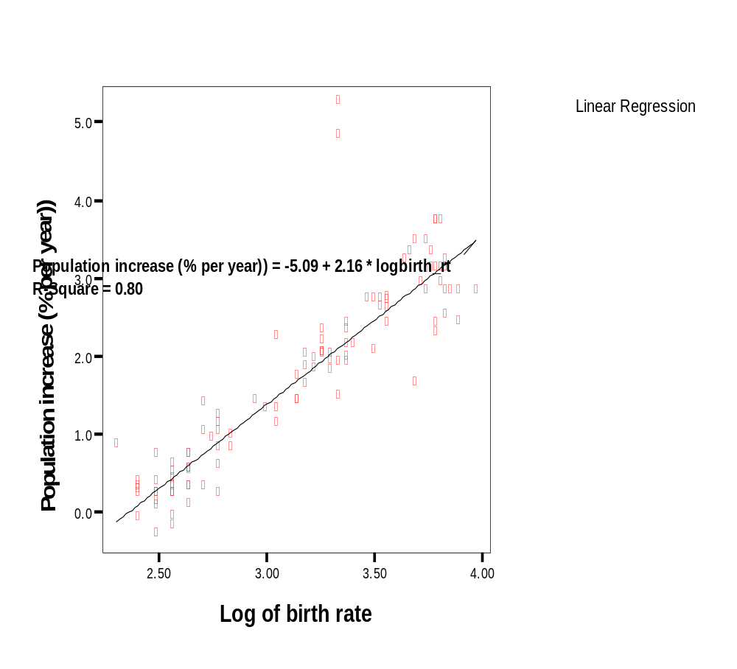

EXE.
REGRESSION
/MISSING LISTWISE
/STATISTICS COEFF OUTS R ANOVA
/CRITERIA=PIN(.05) POUT(.10)
/NOORIGIN
/DEPENDENT pop_incr
/METHOD=ENTER logbirth_rt
/SCATTERPLOT=(*ZRESID ,pop_incr )
/RESIDUALS HIST(ZRESID) NORM(ZRESID)
/CASEWISE PLOT(ZRESID) OUTLIERS(2) .

Regression

[DataSet2] C:\Program Files\SPSS\World95.sav

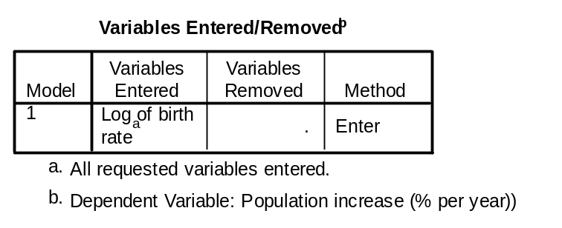

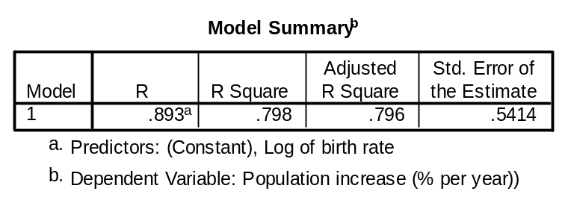

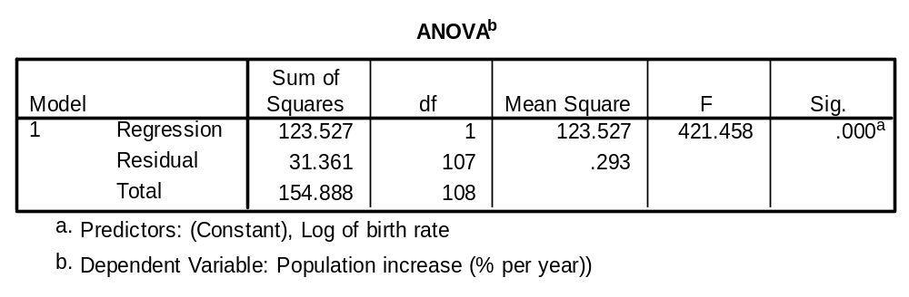

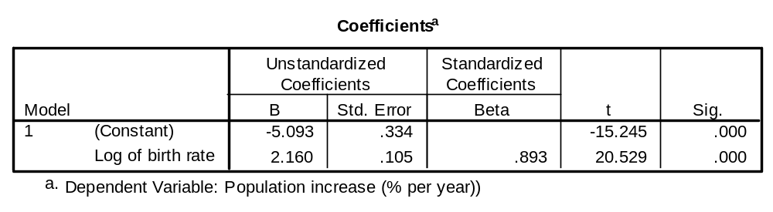

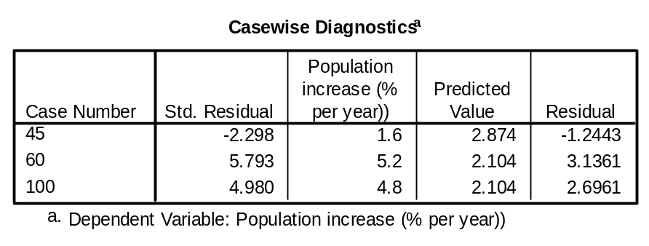

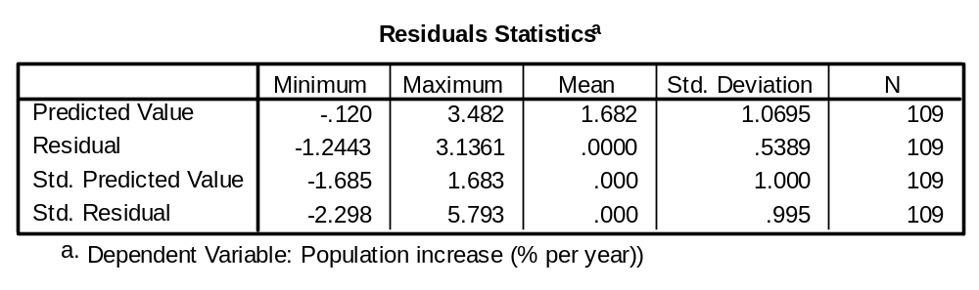

Charts

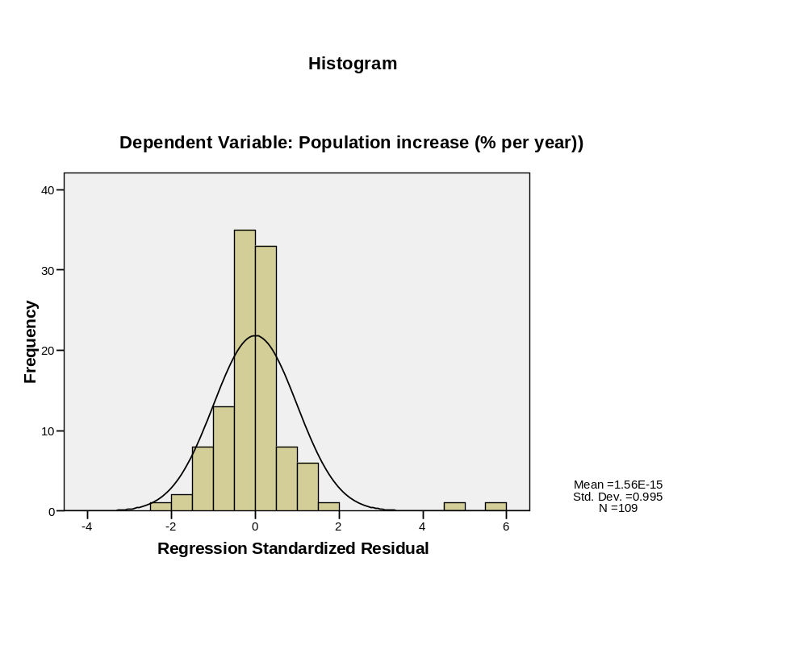
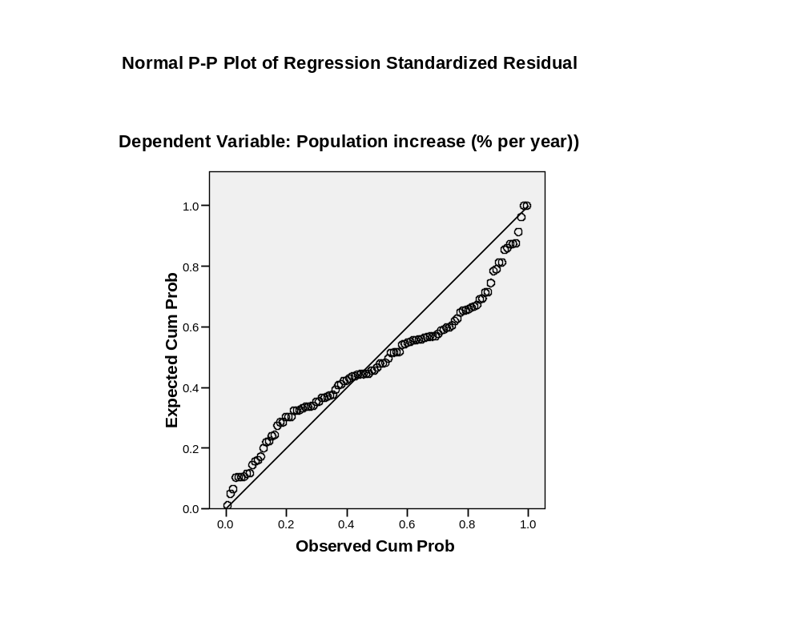
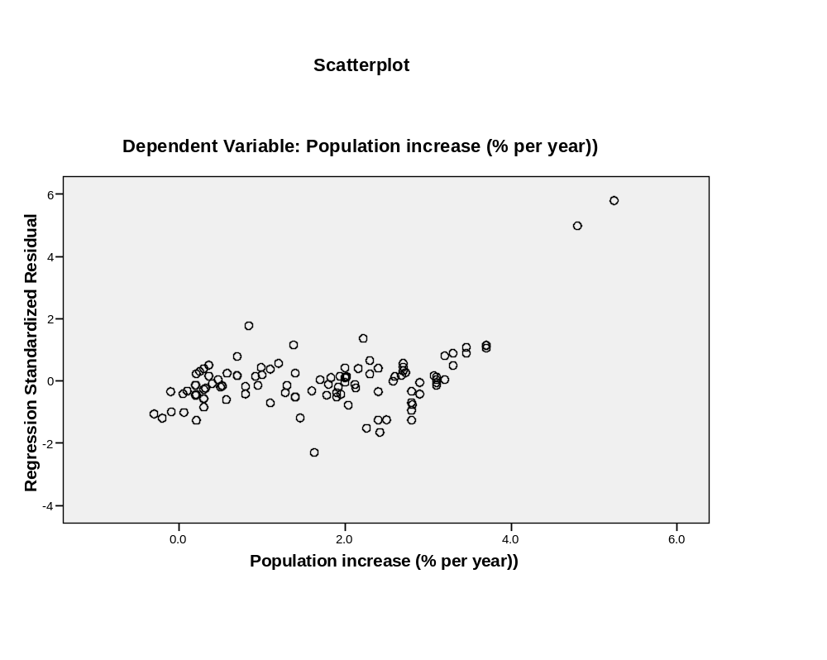
DATASET ACTIVATE DataSet1.
USE ALL.
COMPUTE filter_$=(wrkstat=1).
VARIABLE LABEL filter_$ 'wrkstat=1 (FILTER)'.
VALUE LABELS filter_$ 0 'Not Selected' 1 'Selected'.
FORMAT filter_$ (f1.0).
FILTER BY filter_$.
EXECUTE .
FREQUENCIES
VARIABLES=educ rincom91 /FORMAT=NOTABLE
/STATISTICS=STDDEV MEAN MEDIAN MODE SKEWNESS SESKEW
/HISTOGRAM NORMAL
/ORDER= ANALYSIS .

Frequencies

[DataSet1] C:\Documents and Settings\matsuoh\My Documents\RM530\Data\GSS 1993 (selected for income).sav

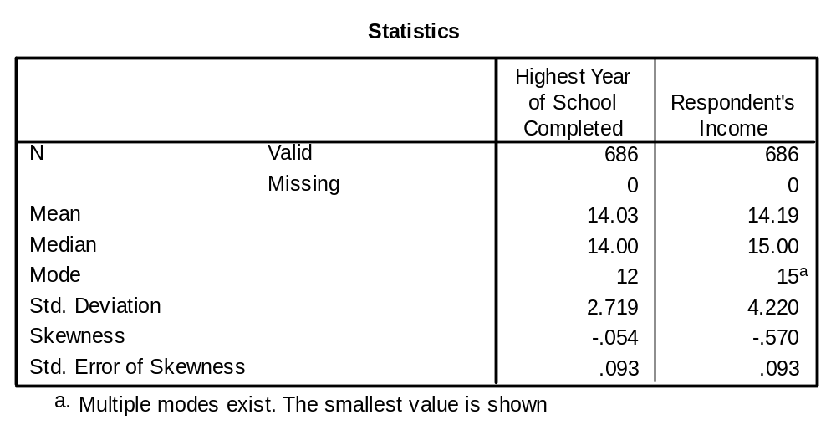

Histogram

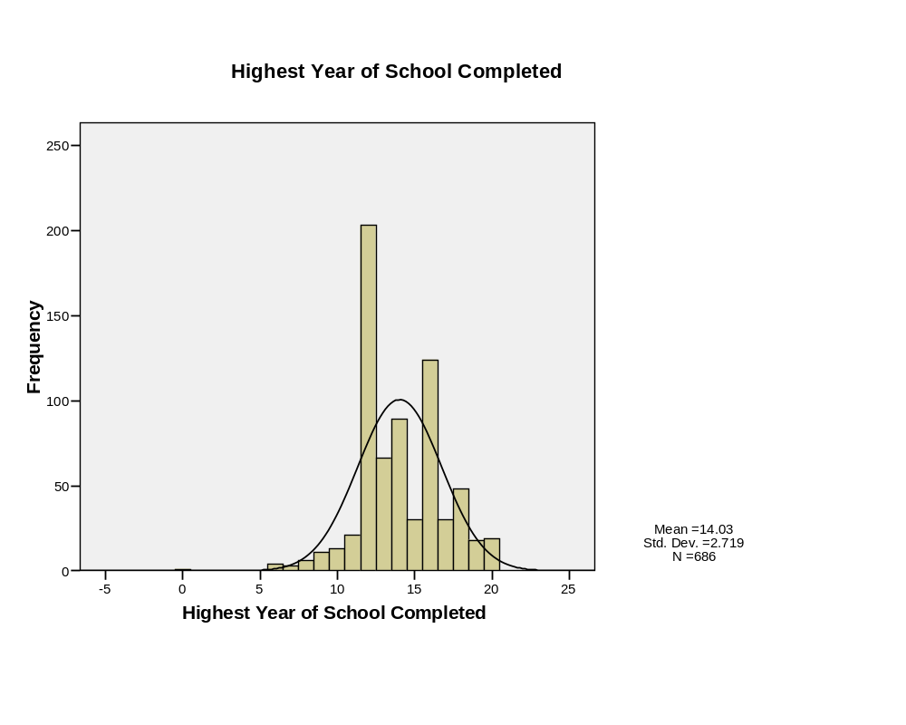
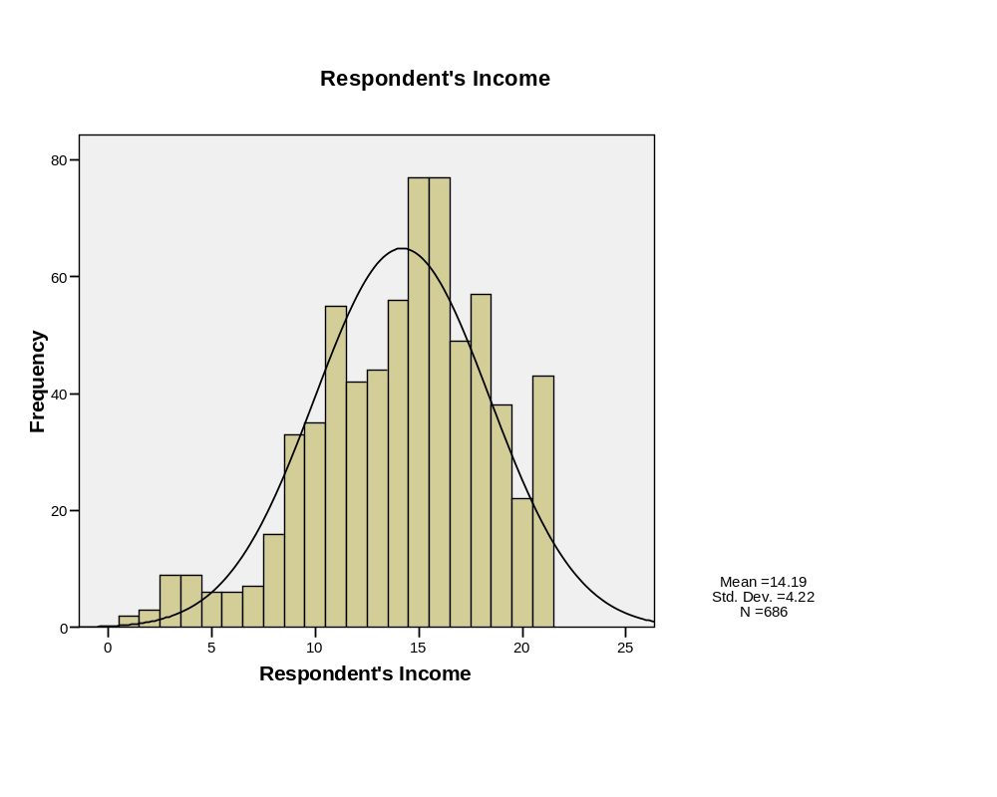
REGRESSION
/MISSING LISTWISE
/STATISTICS COEFF OUTS R ANOVA
/CRITERIA=PIN(.05) POUT(.10)
/NOORIGIN
/DEPENDENT rincom91
/METHOD=ENTER educ
/SCATTERPLOT=(*ZRESID ,rincom91 )
/RESIDUALS HIST(ZRESID) NORM(ZRESID)
/CASEWISE PLOT(ZRESID) OUTLIERS(2) .

Regression

[DataSet1] C:\Documents and Settings\matsuoh\My Documents\RM530\Data\GSS 1993 (selected for income).sav

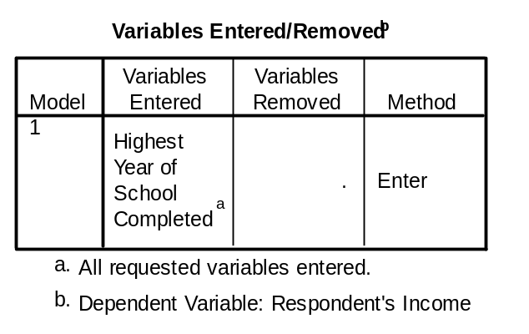

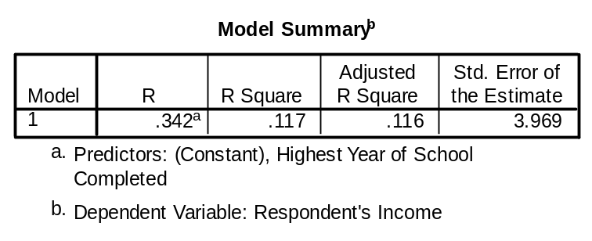

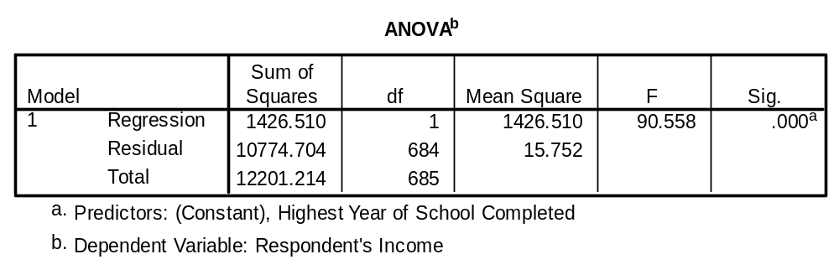

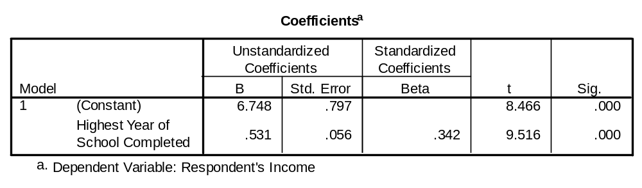

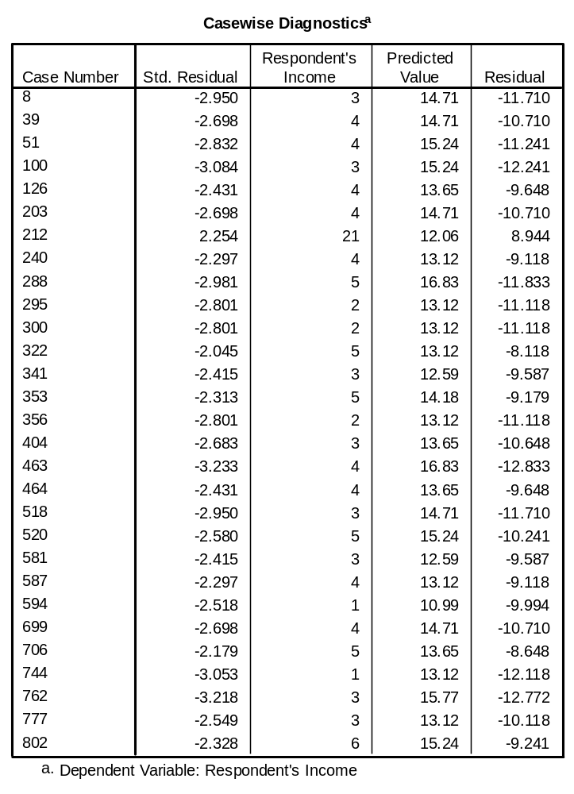

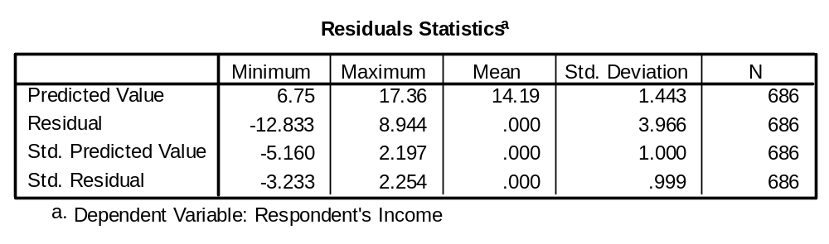

Charts

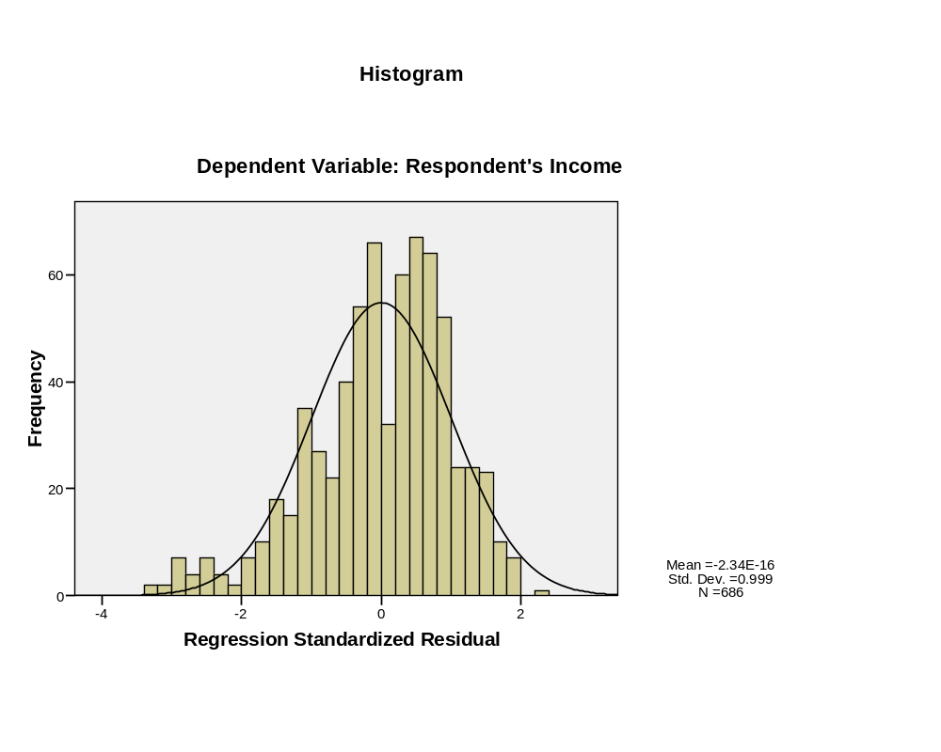
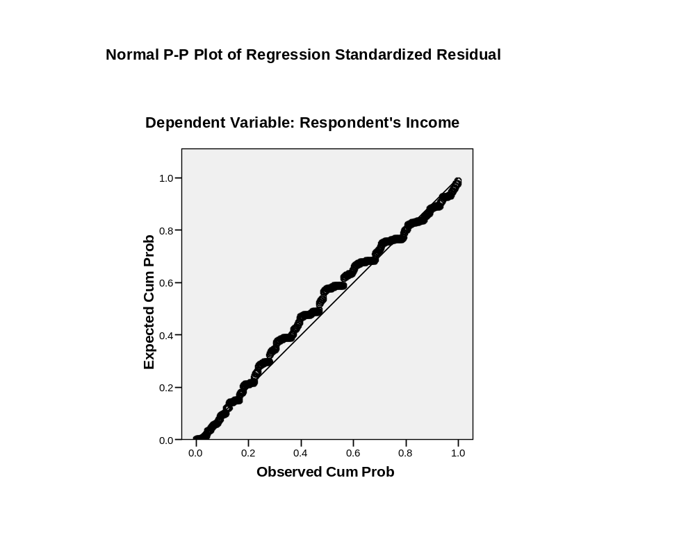
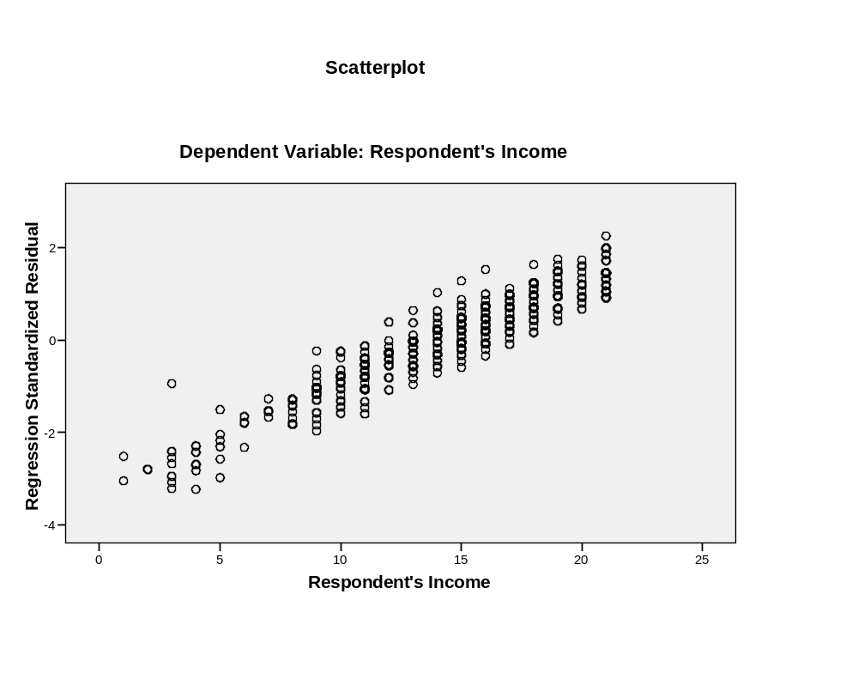
REGRESSION
/MISSING LISTWISE
/STATISTICS COEFF OUTS R ANOVA
/CRITERIA=PIN(.05) POUT(.10)
/NOORIGIN
/DEPENDENT rincom91
/METHOD=ENTER logeduc
/SCATTERPLOT=(*ZRESID ,rincom91 )
/RESIDUALS HIST(ZRESID) NORM(ZRESID)
/CASEWISE PLOT(ZRESID) OUTLIERS(2) .

Regression

[DataSet1] C:\Documents and Settings\matsuoh\My Documents\RM530\Data\GSS 1993 (selected for income).sav

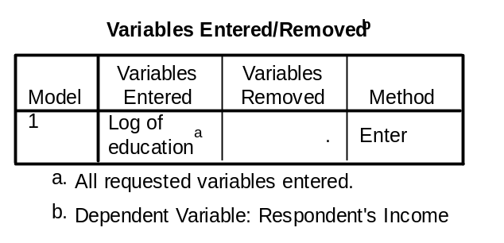

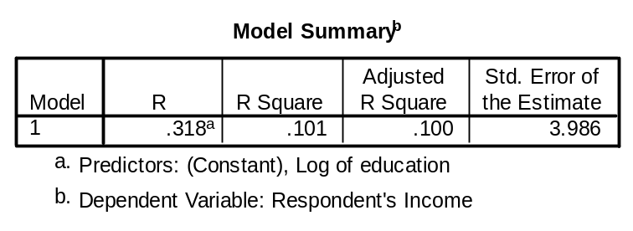

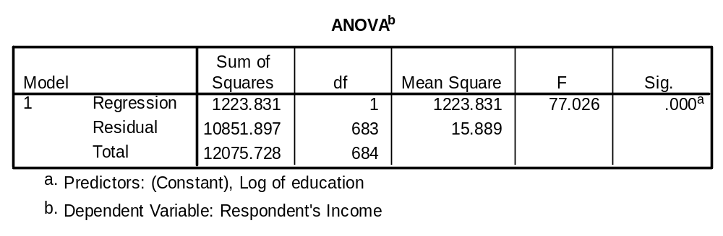

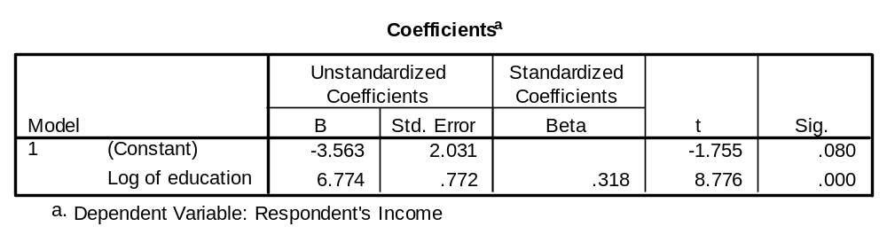x

Y= -3.563 + 6.774 Log of Education

When X=10, Log 10=2.303

Y=-3.563 + 6.774x2.303
=12.037
When x=15, Log 15=2.708

Y=-3.563 + 6.774x2.708
=14.678
Δ2.641

When x=20, Log 20=2.321

Y=-3.563 + 6.774x2.321
=15.721

Δ1.043

Without Log transformation

Y= 6.785 + 0.531 Education
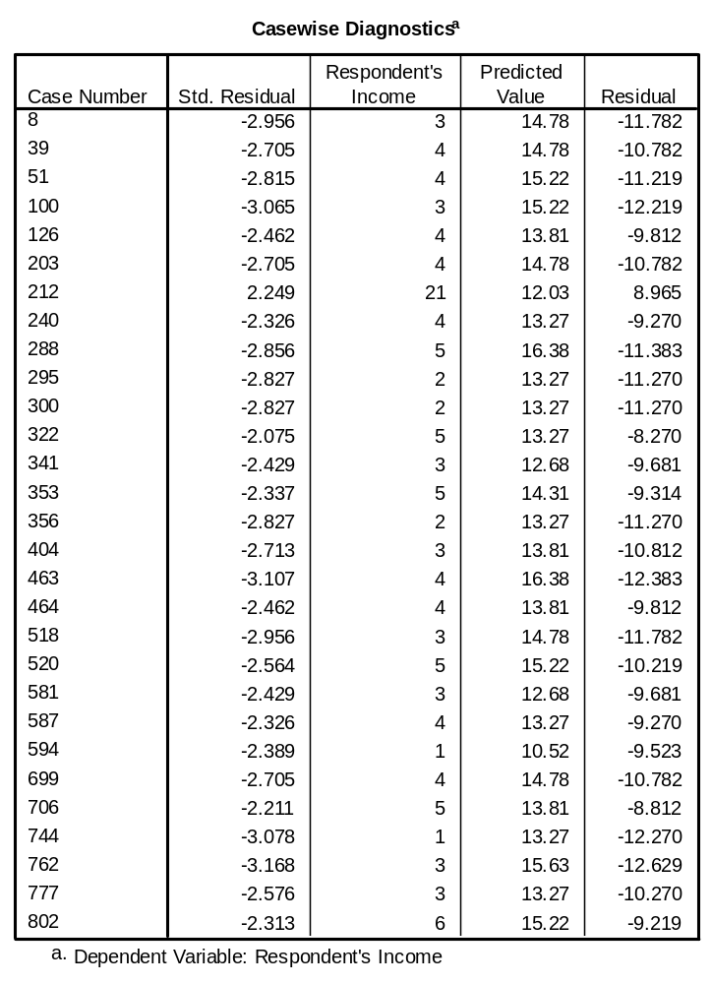

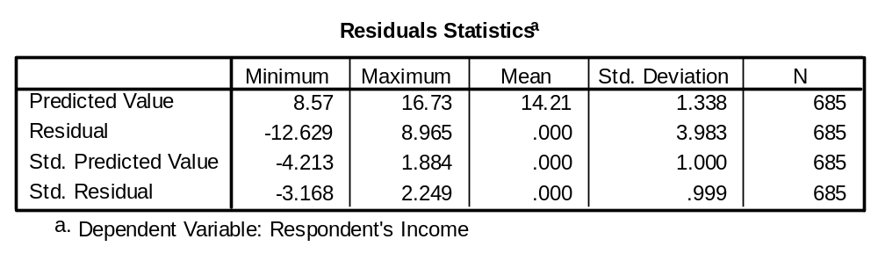

Charts

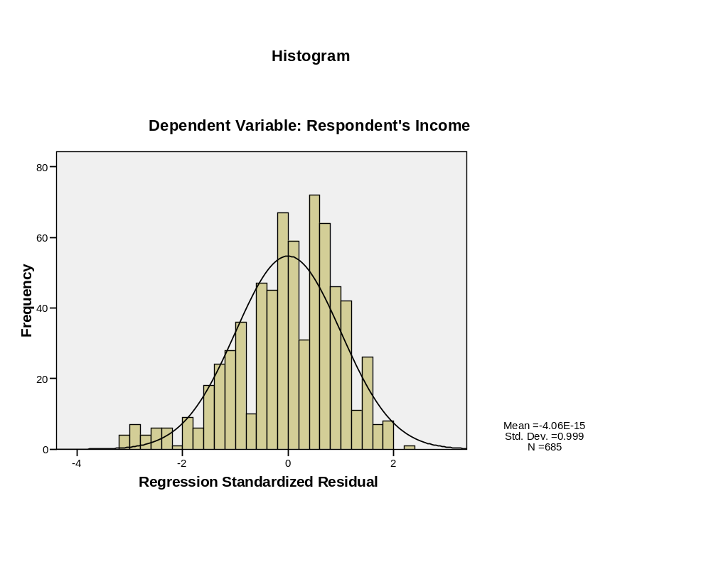
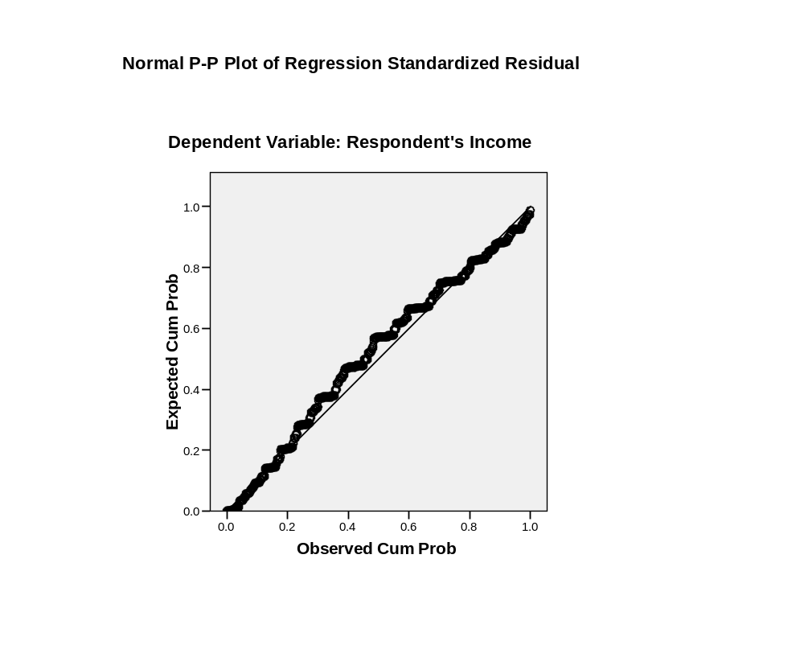
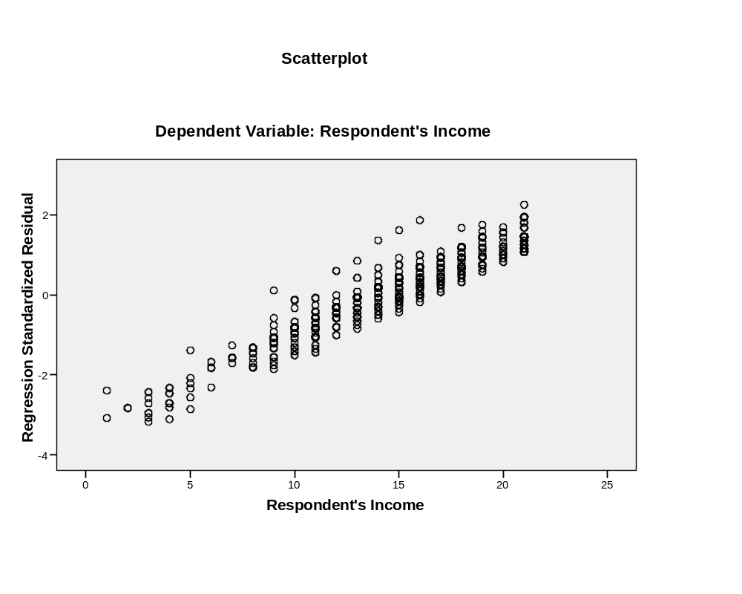
FILTER OFF.
USE ALL.
EXECUTE .

